Primary Reference Weight
# Source: AI Source: Provided by: [Data Path: Persons Table -> ID Column: 1, Name_En Column: Motasem Essam] -> From: [ChatGPT] on [7/17/2026]
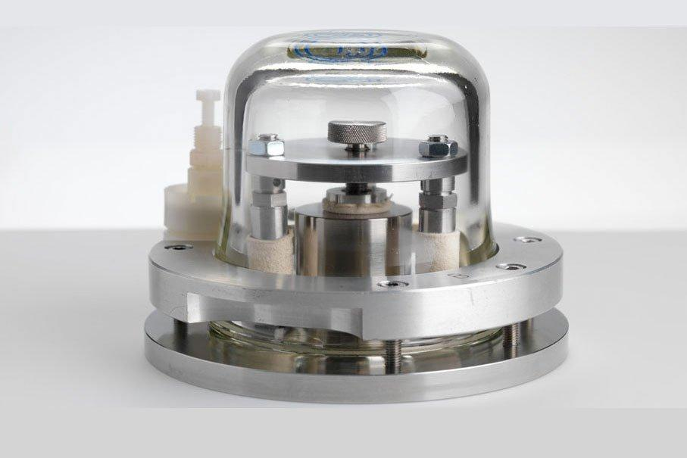
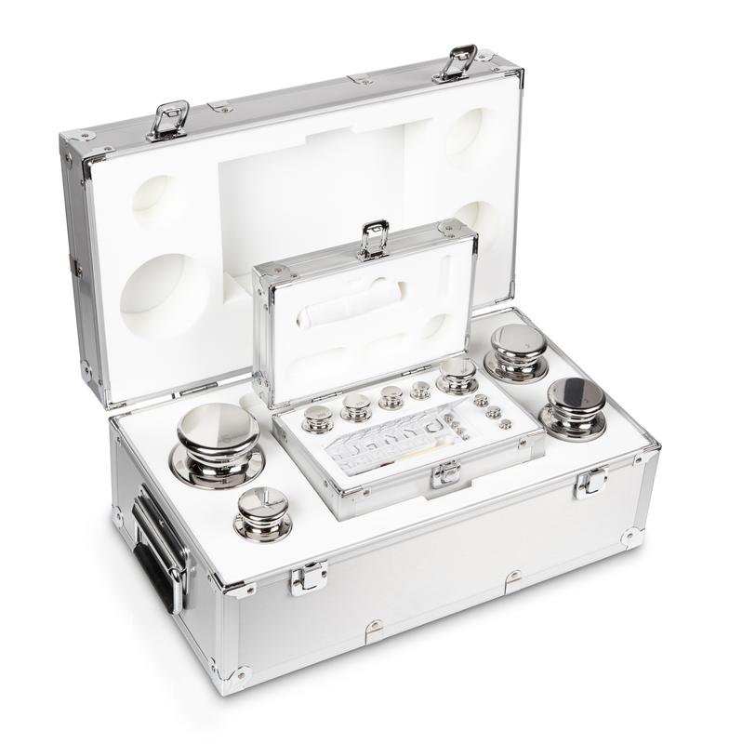
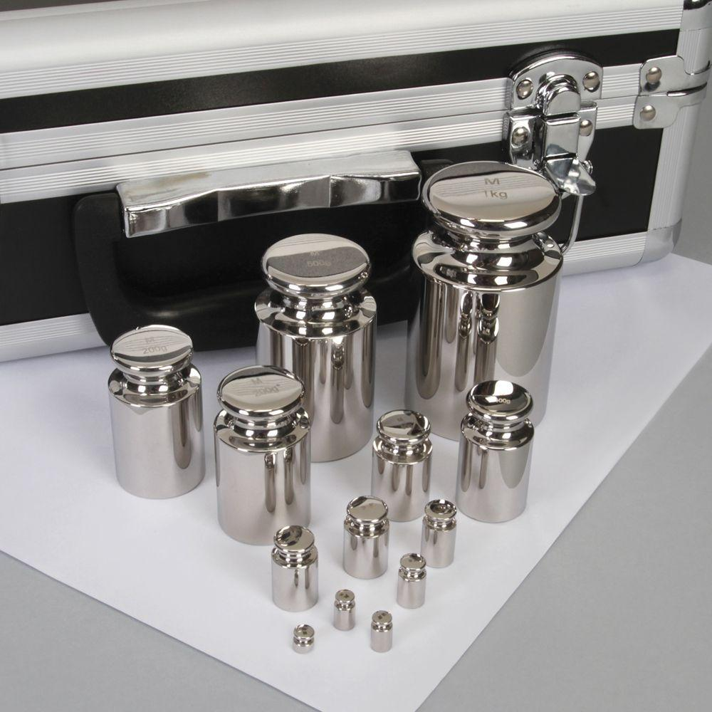
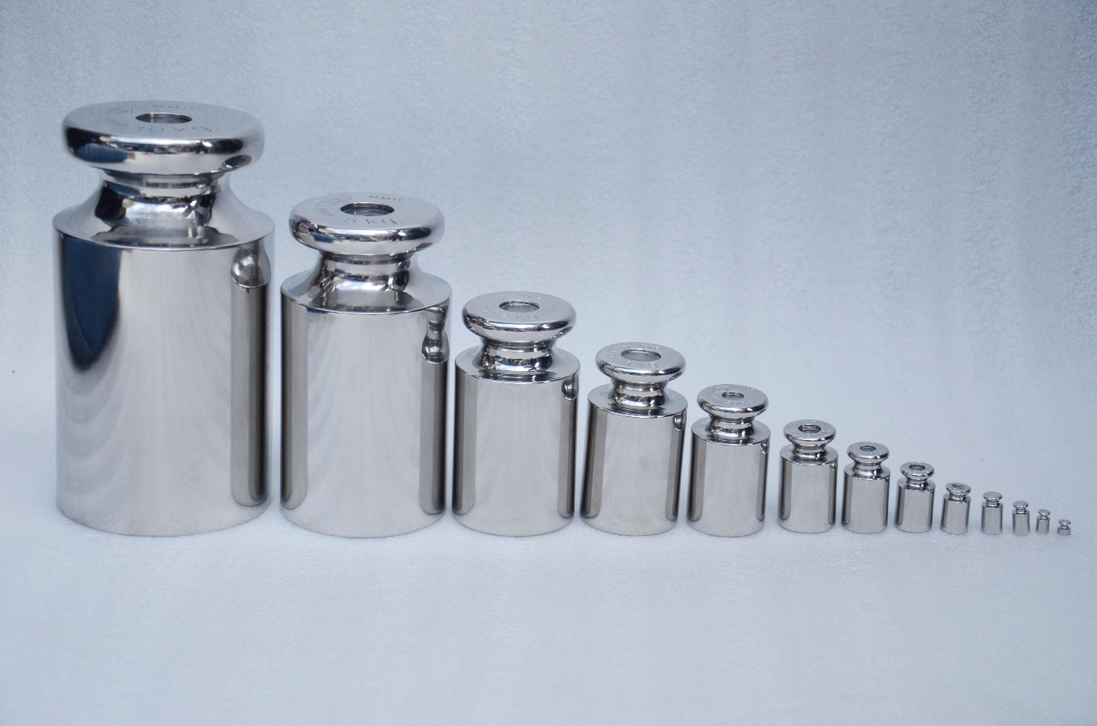
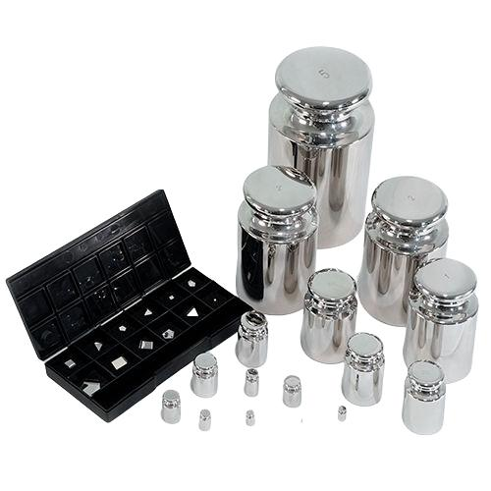
A Primary Reference Weight is the highest-accuracy mass standard used as the top level of the calibration hierarchy within a laboratory, institution, or national metrology system. These weights provide the reference from which all lower-level calibration weights and working weights are calibrated, ensuring traceability to the International System of Units (SI).
Primary reference weights are maintained by National Metrology Institutes (NMIs), accredited calibration laboratories, and scientific research organizations.

Definition
# Source: AI Source: Provided by: [Data Path: Persons Table -> ID Column: 1, Name_En Column: Motasem Essam] -> From: [ChatGPT] on [7/17/2026]
A Primary Reference Weight is a certified, high-precision mass standard that serves as the reference for calibrating secondary reference weights, working weights, and weighing instruments.

Purpose
# Source: AI Source: Provided by: [Data Path: Persons Table -> ID Column: 1, Name_En Column: Motasem Essam] -> From: [ChatGPT] on [7/17/2026]
Primary reference weights are used to:
- Establish traceability to the SI unit of mass.
- Calibrate secondary reference weights.
- Calibrate laboratory calibration weights.
- Support national and international metrology.
- Maintain the highest level of measurement accuracy.
- Verify the performance of accredited calibration laboratories.

Principle of Operation
# Source: AI Source: Provided by: [Data Path: Persons Table -> ID Column: 1, Name_En Column: Motasem Essam] -> From: [ChatGPT] on [7/17/2026]
A primary reference weight provides a known and certified mass.
Other reference weights are compared directly against it using high-precision mass comparators.
The calibration chain then transfers this accuracy to lower-level standards and commercial weighing instruments.

Main Components
# Source: AI Source: Provided by: [Data Path: Persons Table -> ID Column: 1, Name_En Column: Motasem Essam] -> From: [ChatGPT] on [7/17/2026]
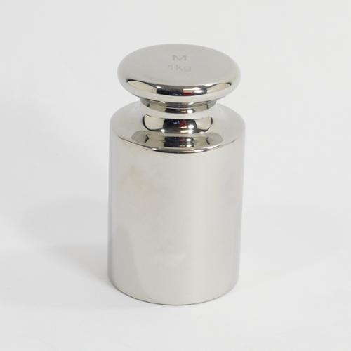
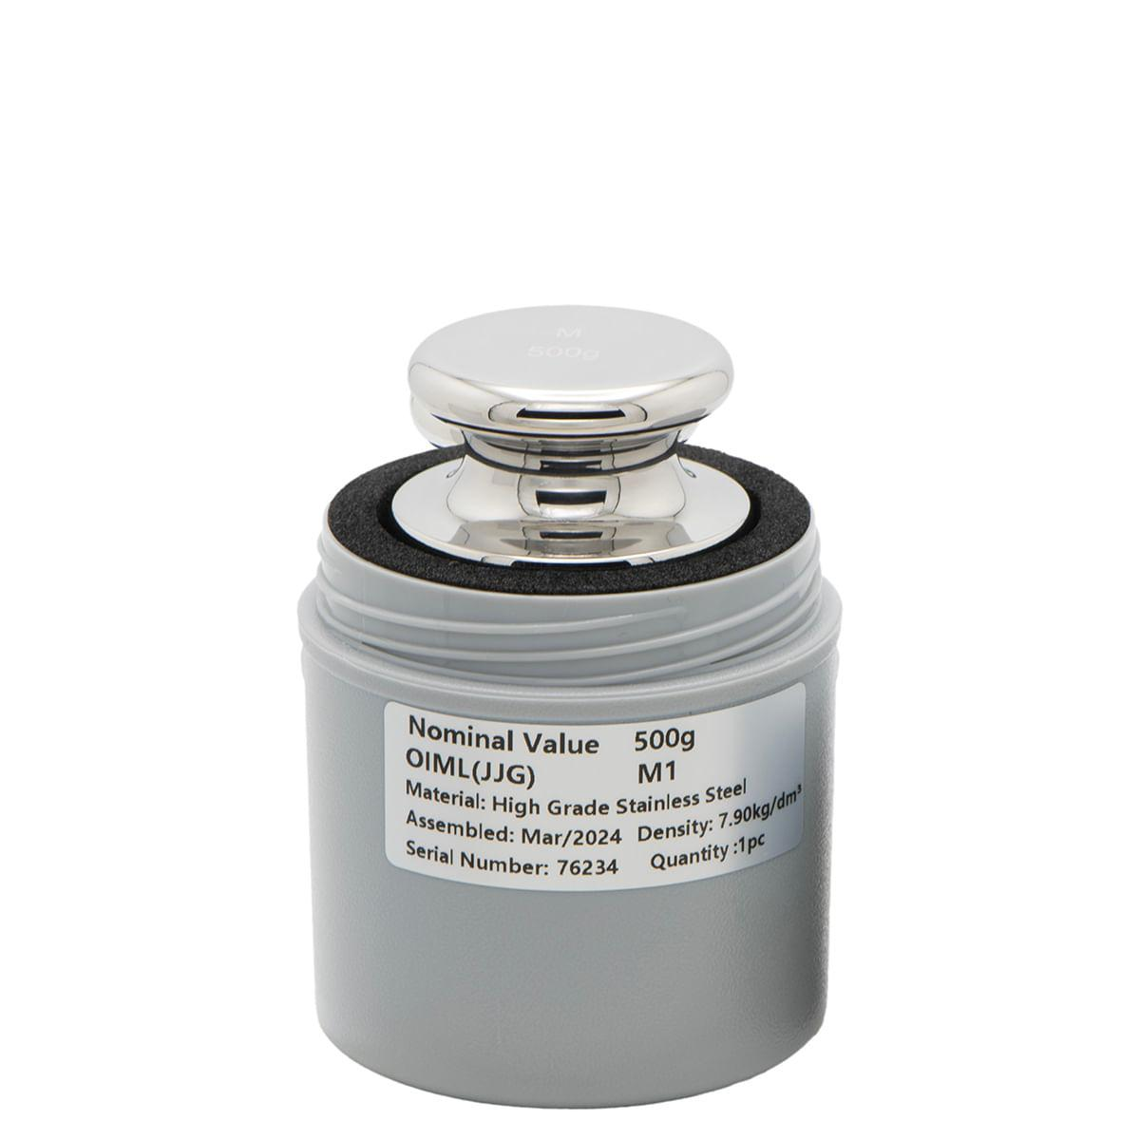
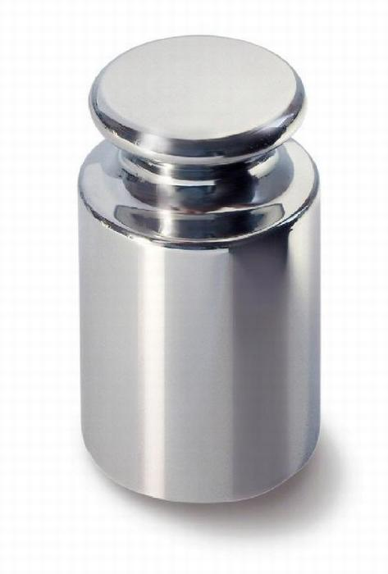
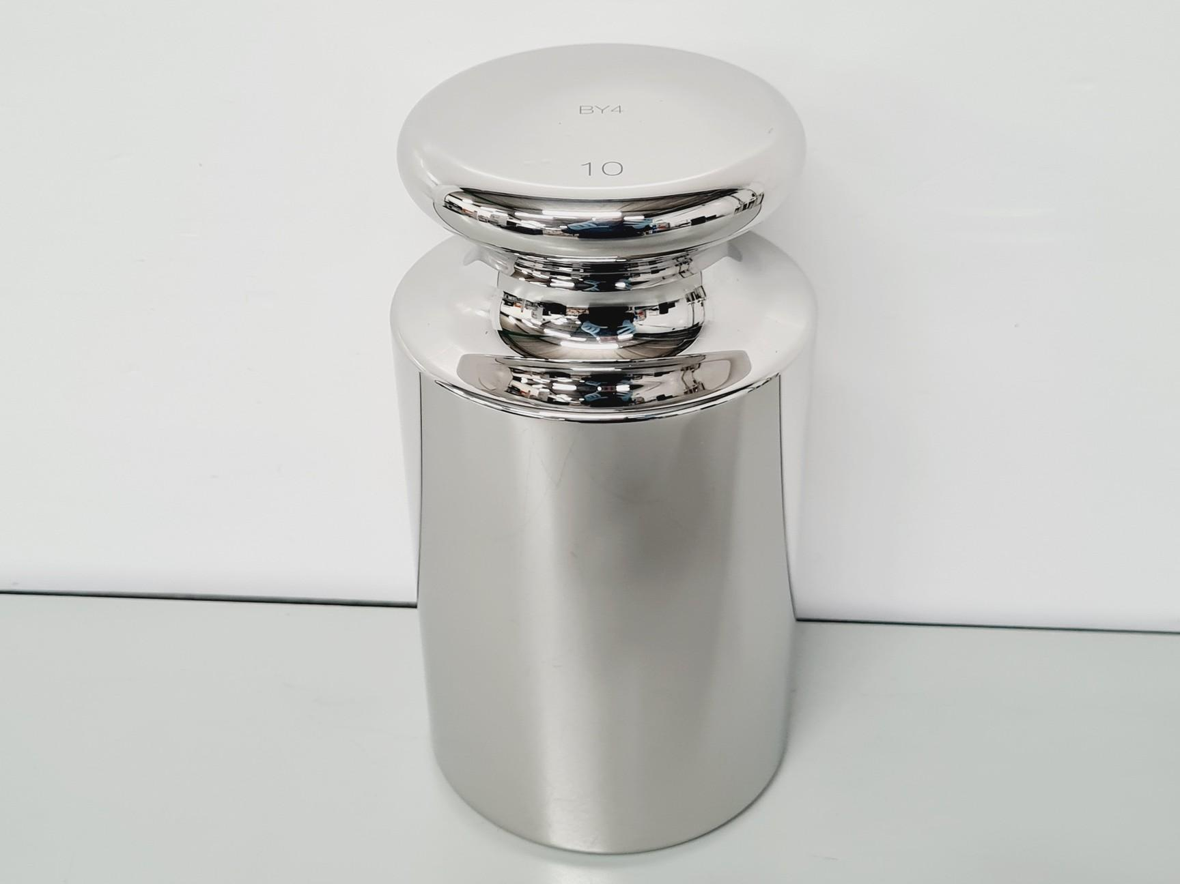
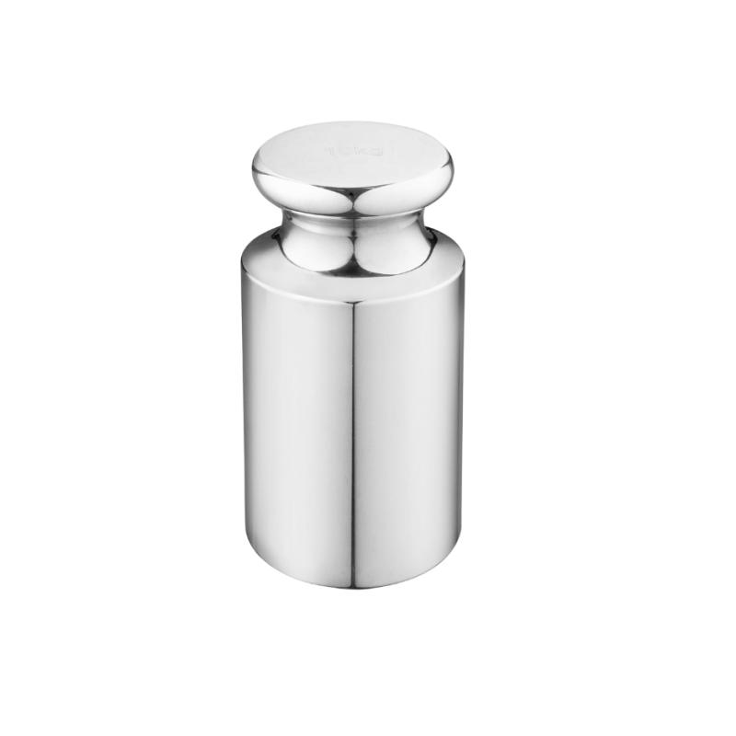
A primary reference weight typically consists of:
- Precision stainless-steel body
- Highly polished, corrosion-resistant surface
- Identification marking or serial number
- Protective storage container
- Accredited calibration certificate

Types of Primary Reference Weights

1. OIML E1 Reference Weights
# Source: AI Source: Provided by: [Data Path: Persons Table -> ID Column: 1, Name_En Column: Motasem Essam] -> From: [ChatGPT] on [7/17/2026]
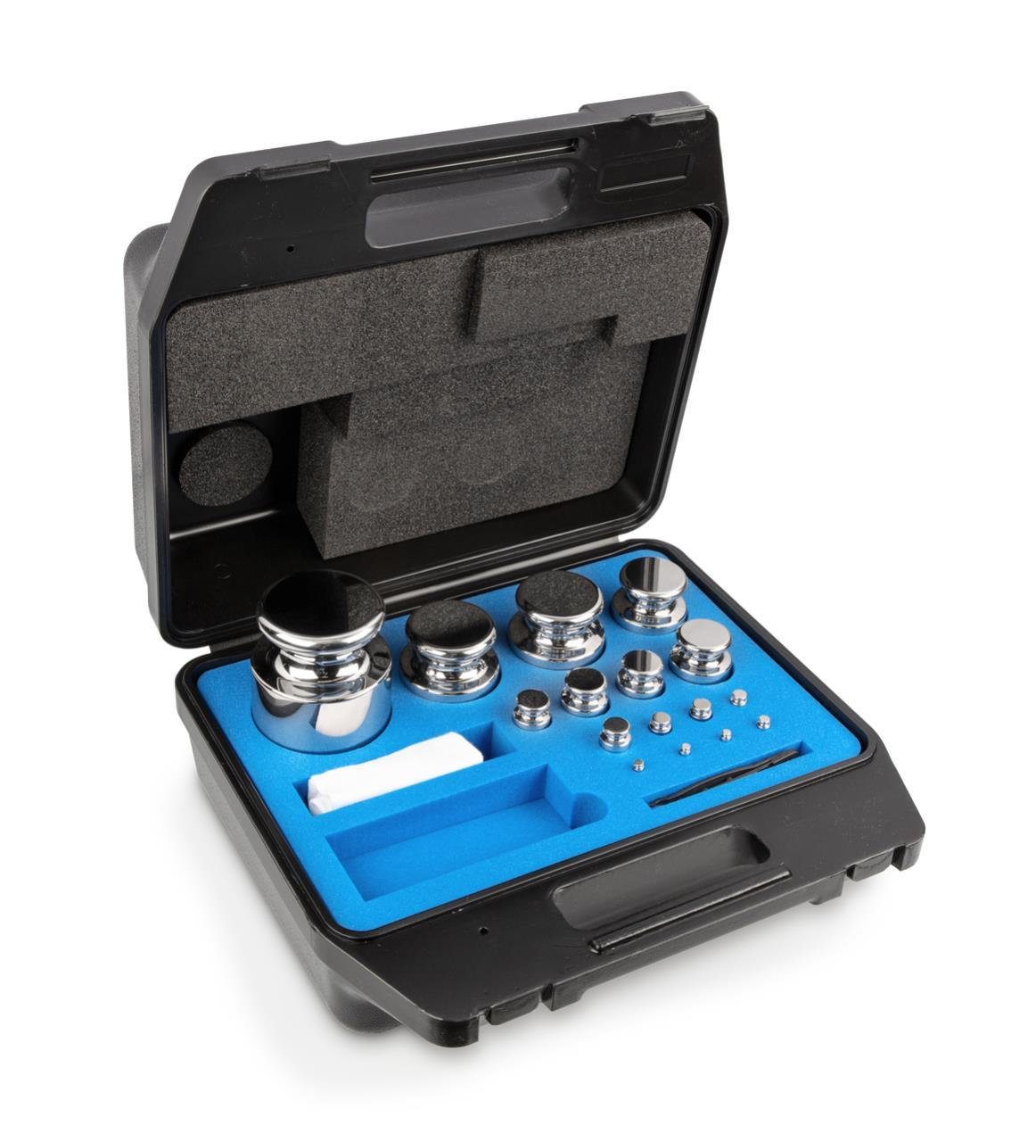
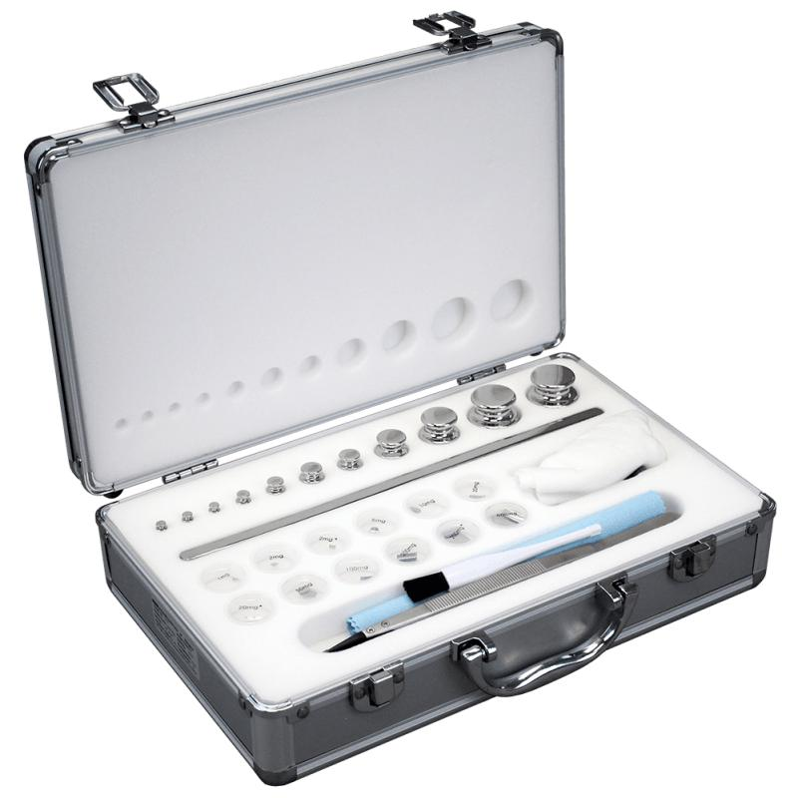
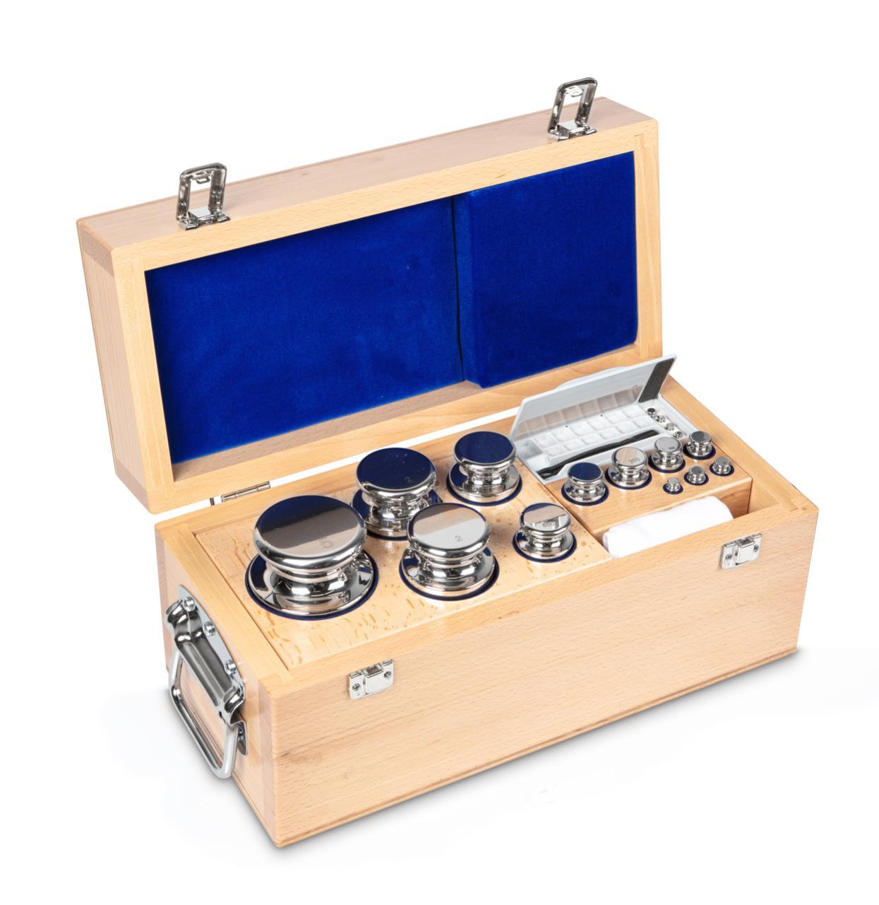
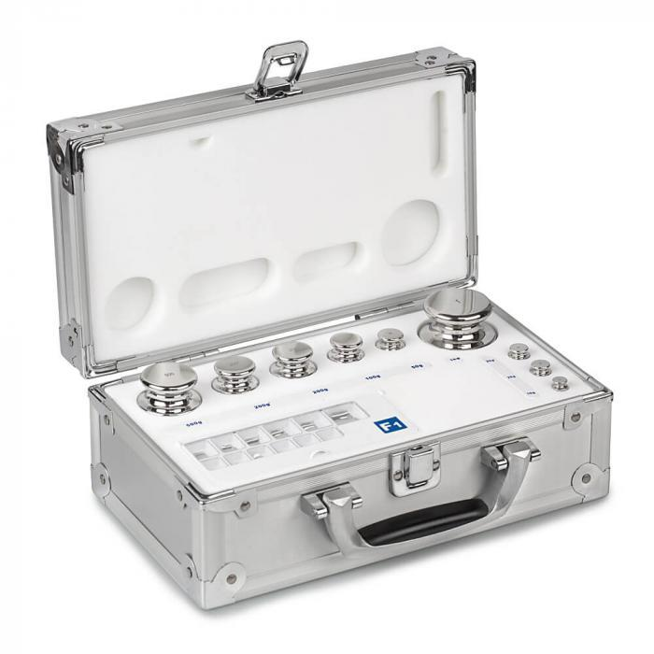
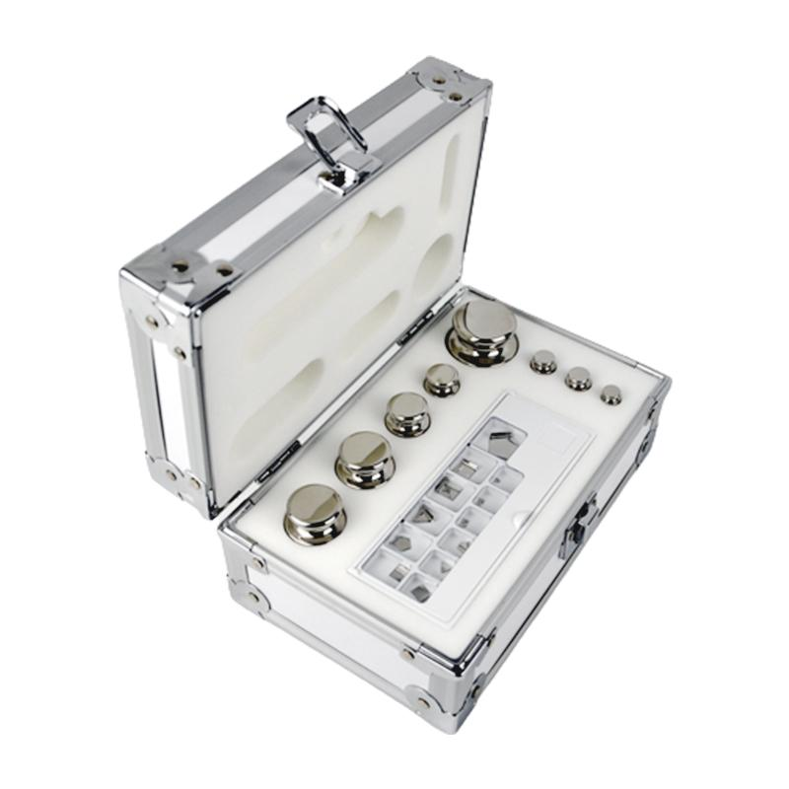
Description
The highest commercially available accuracy class, used for calibrating E2 and lower classes.
Applications
- National metrology institutes
- Accredited calibration laboratories
- Scientific research

2. National Mass Standards
# Source: AI Source: Provided by: [Data Path: Persons Table -> ID Column: 1, Name_En Column: Motasem Essam] -> From: [ChatGPT] on [7/17/2026]

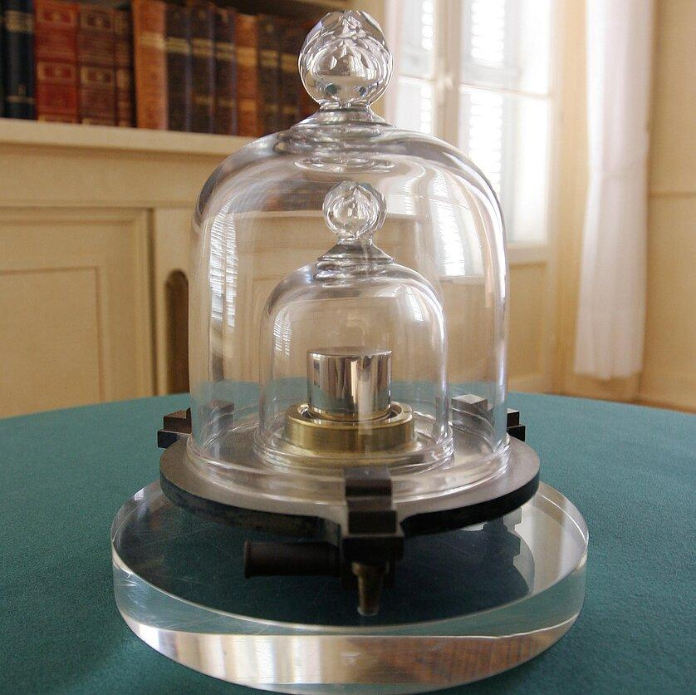

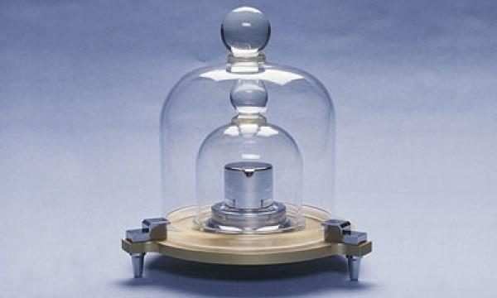
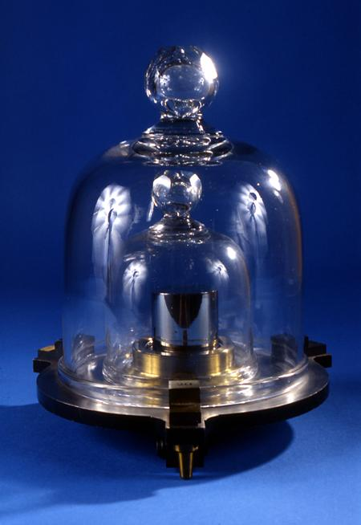
Description
Primary national standards maintained by National Metrology Institutes and used to realize the SI kilogram.
Applications
- National calibration services
- Scientific metrology
- International comparisons

3. Reference Weight Sets
# Source: AI Source: Provided by: [Data Path: Persons Table -> ID Column: 1, Name_En Column: Motasem Essam] -> From: [ChatGPT] on [7/17/2026]
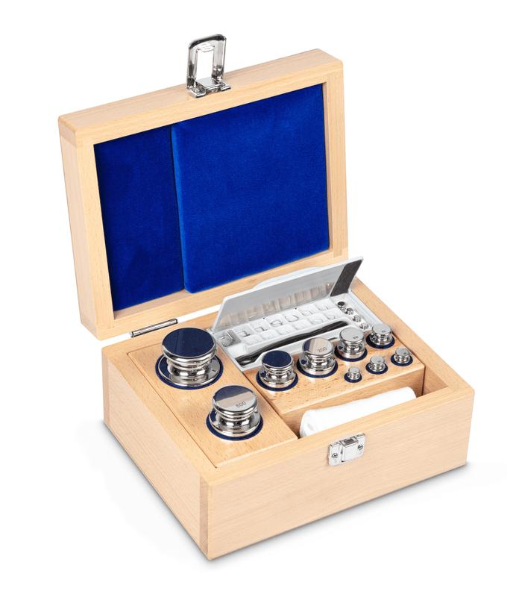

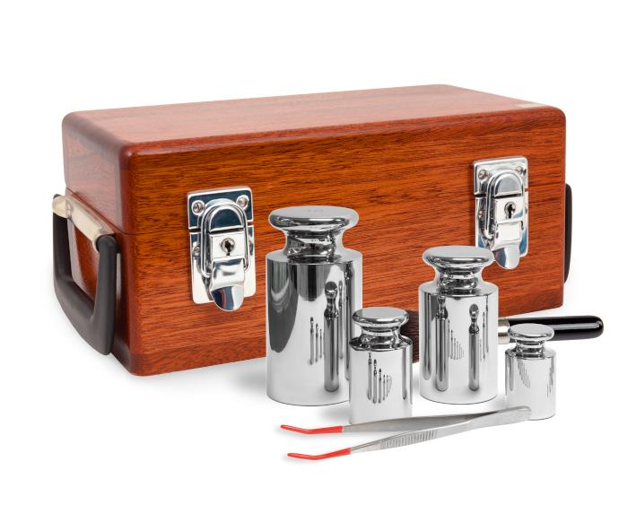
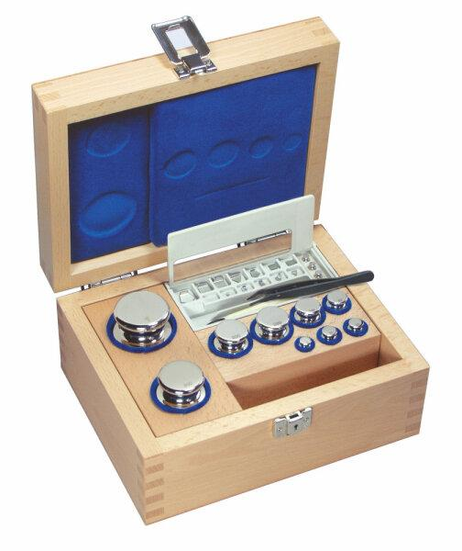
Description
A complete set of high-precision reference masses covering multiple nominal values.
Applications
- Calibration laboratories
- Precision mass comparison
- Scientific institutions

Materials
# Source: AI Source: Provided by: [Data Path: Persons Table -> ID Column: 1, Name_En Column: Motasem Essam] -> From: [ChatGPT] on [7/17/2026]
Primary reference weights are typically manufactured from:
- Non-magnetic stainless steel
- Austenitic stainless steel
- High-stability special alloys

Measuring Units
# Source: AI Source: Provided by: [Data Path: Persons Table -> ID Column: 1, Name_En Column: Motasem Essam] -> From: [ChatGPT] on [7/17/2026]
Primary reference weights are manufactured in:
- Milligram (mg)
- Gram (g)
- Kilogram (kg)

Measuring Range
# Source: AI Source: Provided by: [Data Path: Persons Table -> ID Column: 1, Name_En Column: Motasem Essam] -> From: [ChatGPT] on [7/17/2026]
Primary reference weights are available in standardized nominal masses.
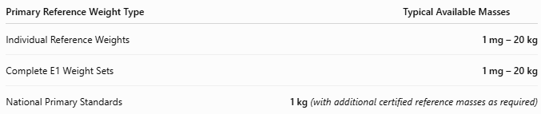
Primary Reference Weight Type | Typical Available Masses
Individual Reference Weights | 1 mg – 20 kg
Complete E1 Weight Sets | 1 mg – 20 kg
National Primary Standards | 1 kg (with additional certified reference masses as required)

Resolution
# Source: AI Source: Provided by: [Data Path: Persons Table -> ID Column: 1, Name_En Column: Motasem Essam] -> From: [ChatGPT] on [7/17/2026]
Primary reference weights do not perform measurements, therefore they do not have a measurement resolution.
Instead, they are manufactured in highly accurate nominal mass values.
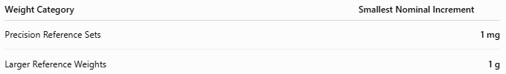
Weight Category | Smallest Nominal Increment
Precision Reference Sets | 1 mg
Larger Reference Weights | 1 g

Accuracy
# Source: AI Source: Provided by: [Data Path: Persons Table -> ID Column: 1, Name_En Column: Motasem Essam] -> From: [ChatGPT] on [7/17/2026]
Accuracy is determined by the OIML E1 class, which has the smallest permissible error of all commercially available weight classes.
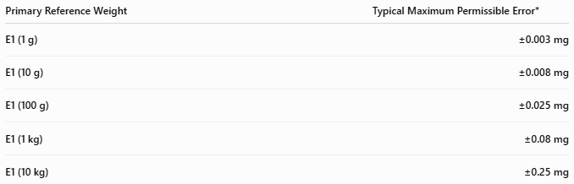
Primary Reference Weight | Typical Maximum Permissible Error*
E1 (1 g) | ±0.003 mg
E1 (10 g) | ±0.008 mg
E1 (100 g) | ±0.025 mg
E1 (1 kg) | ±0.08 mg
E1 (10 kg) | ±0.25 mg
*Maximum permissible errors are specified by OIML R111 and increase with nominal mass.
Notes
- Primary reference weights are the most accurate commercially available mass standards.
- They are calibrated directly against national or international standards.
- They are used to calibrate E2, F1, F2, M1, and other lower-class weights.
- Handling is extremely controlled to prevent contamination or mass change.

How to Use Primary Reference Weights
# Source: AI Source: Provided by: [Data Path: Persons Table -> ID Column: 1, Name_En Column: Motasem Essam] -> From: [ChatGPT] on [7/17/2026]
- Use a calibrated mass comparator.
- Handle with gloves or forceps.
- Allow weights to stabilize to room temperature.
- Compare against the weight being calibrated.
- Record measurement uncertainty and results.

Applications
# Source: AI Source: Provided by: [Data Path: Persons Table -> ID Column: 1, Name_En Column: Motasem Essam] -> From: [ChatGPT] on [7/17/2026]
Primary reference weights are used in:
- National Metrology Institutes (NMIs)
- Accredited calibration laboratories
- Scientific research laboratories
- Precision manufacturing
- Pharmaceutical industries
- Aerospace laboratories

Advantages
# Source: AI Source: Provided by: [Data Path: Persons Table -> ID Column: 1, Name_En Column: Motasem Essam] -> From: [ChatGPT] on [7/17/2026]
Primary reference weights:
- Provide the highest available mass accuracy.
- Maintain SI traceability.
- Offer extremely low uncertainty.
- Serve as the foundation of the mass calibration hierarchy.

Limitations
# Source: AI Source: Provided by: [Data Path: Persons Table -> ID Column: 1, Name_En Column: Motasem Essam] -> From: [ChatGPT] on [7/17/2026]
Primary reference weights:
- Are very expensive.
- Require controlled environmental conditions.
- Must be handled with extreme care.
- Require periodic recalibration by accredited laboratories.

Sources of Error
# Source: AI Source: Provided by: [Data Path: Persons Table -> ID Column: 1, Name_En Column: Motasem Essam] -> From: [ChatGPT] on [7/17/2026]
Weight Errors
- Surface contamination
- Oxidation (if improperly stored)
- Mechanical damage

User Errors
- Touching with bare hands
- Improper cleaning
- Mishandling

Environmental Errors
- Air buoyancy
- Temperature changes
- Humidity
- Dust
- Static electricity

Comparison with Other Reference Weights
# Source: AI Source: Provided by: [Data Path: Persons Table -> ID Column: 1, Name_En Column: Motasem Essam] -> From: [ChatGPT] on [7/17/2026]
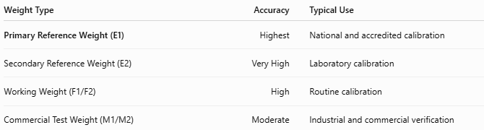
Weight Type | Accuracy | Typical Use
Primary Reference Weight (E1) | Highest | National and accredited calibration
Secondary Reference Weight (E2) | Very High | Laboratory calibration
Working Weight (F1/F2) | High | Routine calibration
Commercial Test Weight (M1/M2) | Moderate | Industrial and commercial verification

Care and Maintenance
# Source: AI Source: Provided by: [Data Path: Persons Table -> ID Column: 1, Name_En Column: Motasem Essam] -> From: [ChatGPT] on [7/17/2026]
To preserve accuracy:
- Store in a sealed protective case.
- Handle only with gloves or tweezers.
- Avoid touching polished surfaces.
- Keep away from moisture and dust.
- Recalibrate periodically through an accredited laboratory.

Common Mistakes
# Source: AI Source: Provided by: [Data Path: Persons Table -> ID Column: 1, Name_En Column: Motasem Essam] -> From: [ChatGPT] on [7/17/2026]
- Handling with bare hands.
- Mixing E1 weights with lower-class weights.
- Storing outside controlled environments.
- Using damaged or contaminated weights.

Key Points
# Source: AI Source: Provided by: [Data Path: Persons Table -> ID Column: 1, Name_En Column: Motasem Essam] -> From: [ChatGPT] on [7/17/2026]
- A Primary Reference Weight is the highest-accuracy mass standard used in the calibration hierarchy.
- It provides traceability to the SI kilogram.
- Common forms:
  - OIML E1 Individual Weights
  - National Mass Standards
  - E1 Reference Weight Sets
- Used by:
  - National Metrology Institutes
  - Accredited Calibration Laboratories
  - Scientific Research Centers

Conclusion
# Source: AI Source: Provided by: [Data Path: Persons Table -> ID Column: 1, Name_En Column: Motasem Essam] -> From: [ChatGPT] on [7/17/2026]
A Primary Reference Weight is the highest level of practical mass standard used to establish and maintain traceability to the International System of Units (SI). Manufactured to the stringent OIML E1 accuracy class and maintained under carefully controlled conditions, these weights form the foundation of the global mass calibration hierarchy, ensuring that all lower-level calibration weights, laboratory balances, and commercial weighing systems achieve reliable, consistent, and internationally comparable measurements.

